**bibliographic Information ツ**

Author(s):

[Ivan Maurović](https://ieeexplore.ieee.org/author/37085725871); [Marija Seder](https://ieeexplore.ieee.org/author/38228267600); [Kruno Lenac](https://ieeexplore.ieee.org/author/37085727918); [Ivan Petrović](https://ieeexplore.ieee.org/author/37564131900)

Title of **article** or **book** (if a chapter in a book, put the chapter # and title here, and put the title of the book in “Title of publication”):

Title of publication, including Vol., Num., date (if article in magazine, newspaper, or journal):

Path Planning for Active SLAM Based on the D* Algorithm With Negative Edge Weights

Page numbers (if article in magazine, newspaper, or journal):

1321-1331

Publisher:

Date published:

Aug 2018

URL (if applicable):

<https://ieeexplore.ieee.org/abstract/document/7878681>

MLA citation:

I. Maurović, M. Seder, K. Lenac and I. Petrović, "Path Planning for Active SLAM Based on the D* Algorithm With Negative Edge Weights," in IEEE Transactions on Systems, Man, and Cybernetics: Systems, vol. 48, no. 8, pp. 1321-1331, Aug. 2018, doi: 10.1109/TSMC.2017.2668603.

keywords: {Simultaneous localization and mapping;Uncertainty;Trajectory;Heuristic algorithms;Active SLAM;dynamic environment;exploration;negative edge weight in a graph;path planning;simultaneous localization and mapping (SLAM)},

**Direct quotes: *Include Page #s***(For each quote, provide some context and/or analysis; you may also want to re-state the information in your own words. Quotes from your sources, and your understanding of them, will make up the bulk of your literature review)

1. 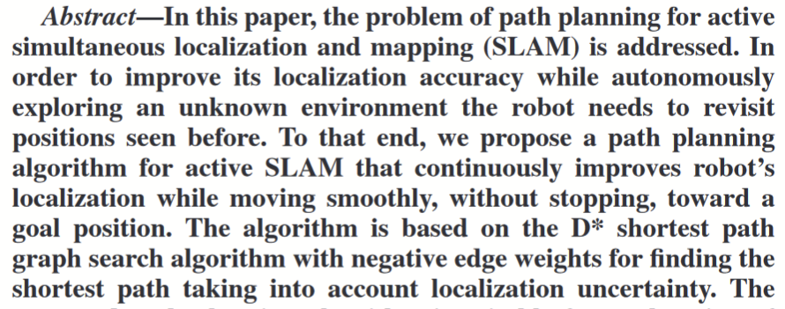p1321
2. 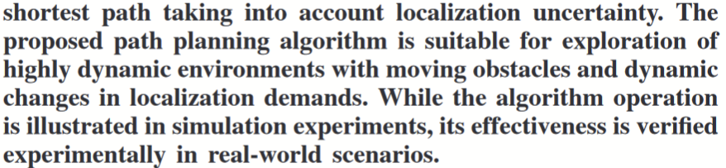p1321
3. 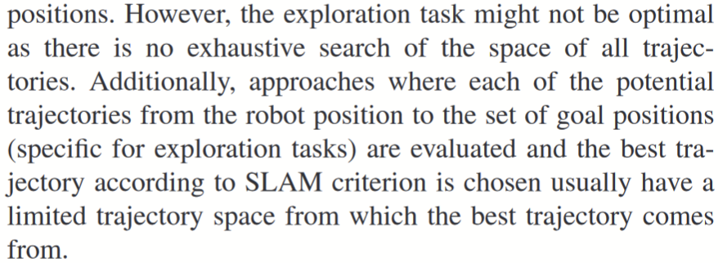1322
4. 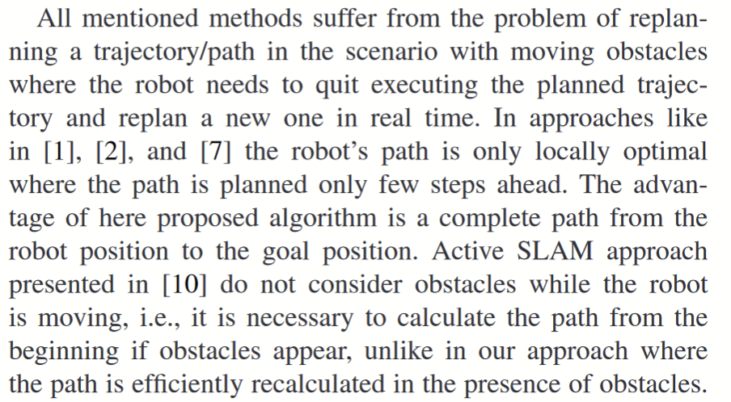p1322
5. The robot starts with an unknown map of the environment and takes an initial laser scan. Based on the first laser scan it builds an initial polygonal map of the environment and calculates the next positions from where to take the next scan to maximize the amount of unexplored area which can be seen from the next scan. The exploration is finished when the whole environment is covered by the laser sensor. The algorithm gives a goal positions in front of the lines which divide known and unknown areas. In our previous work, we tested the algorithm on a complex 3-D environment. Details of the exploration method can be found in [19]. P1322-1323
6. 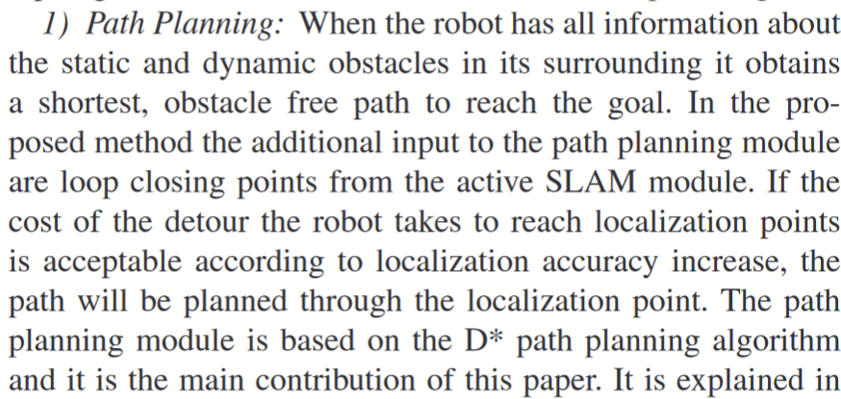p1324
7. 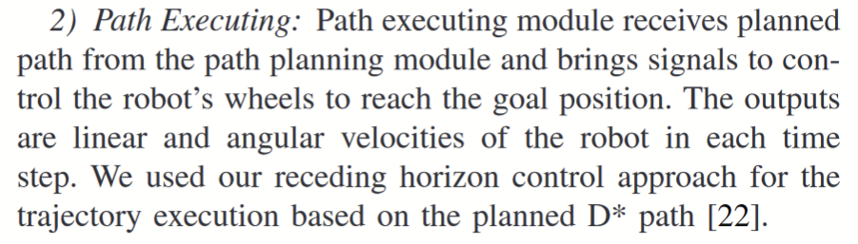p1324
8. 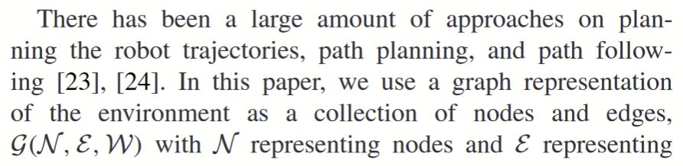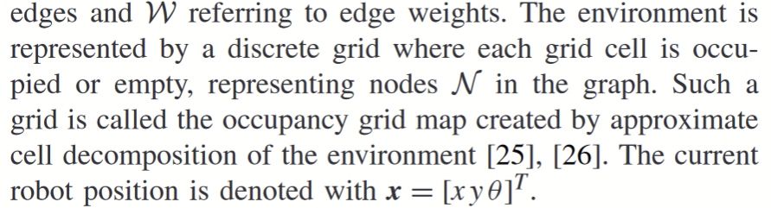p1324
9. 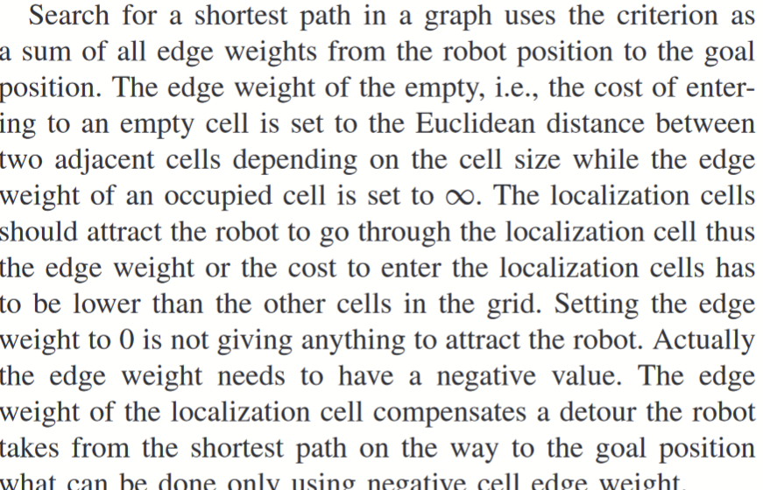p1324
10. 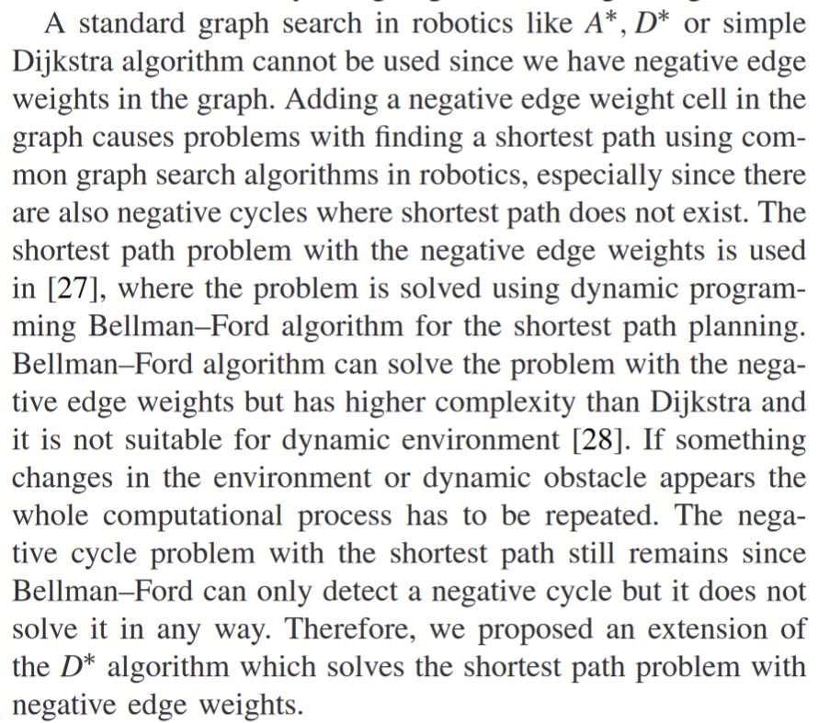p1324
11. 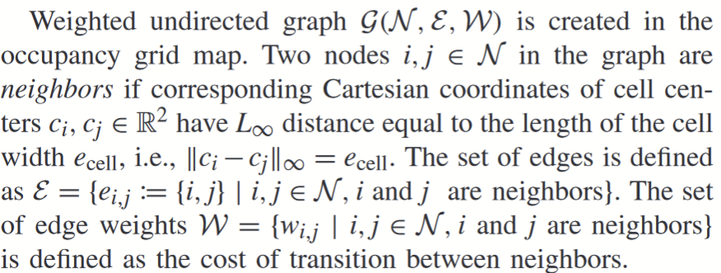p1324
12. 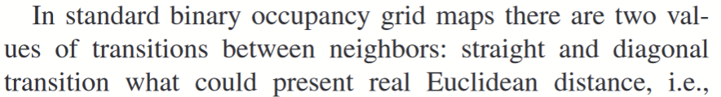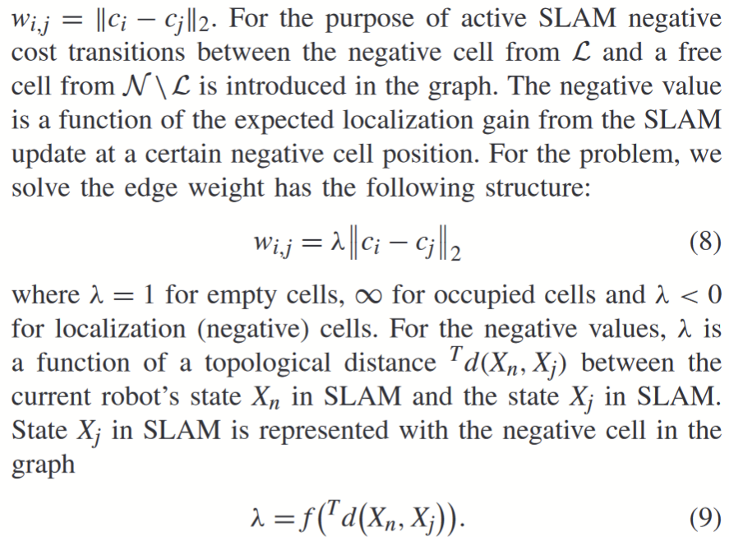p1324-1325
13. 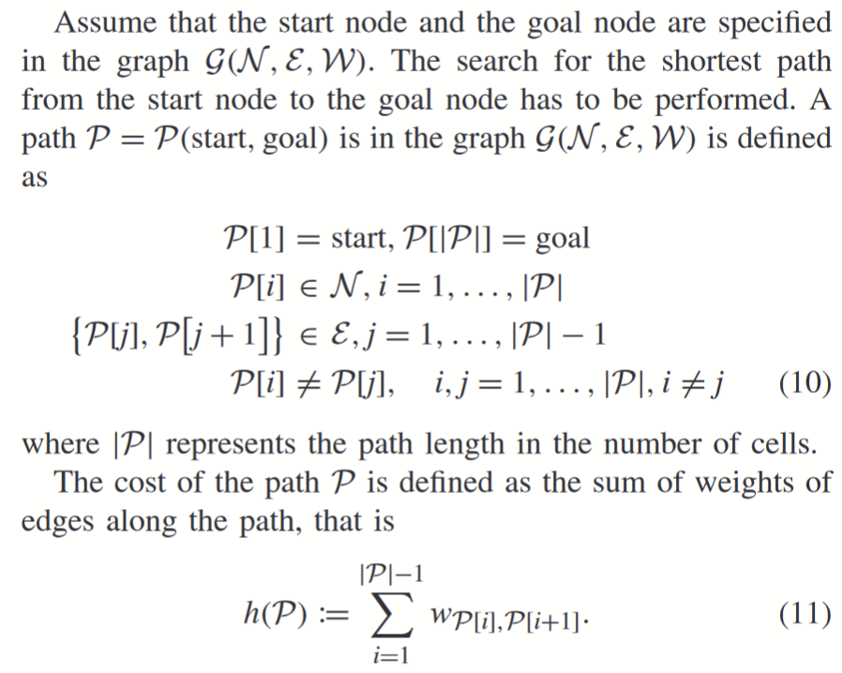p1325
14. 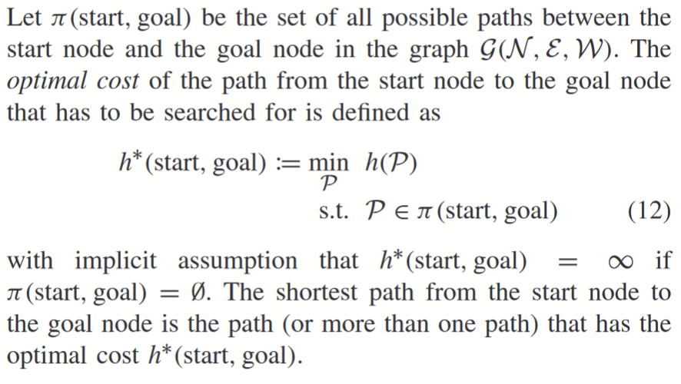p1325
15. 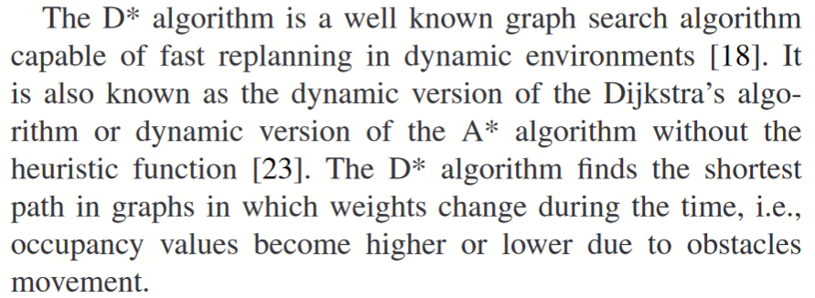p1325
16. 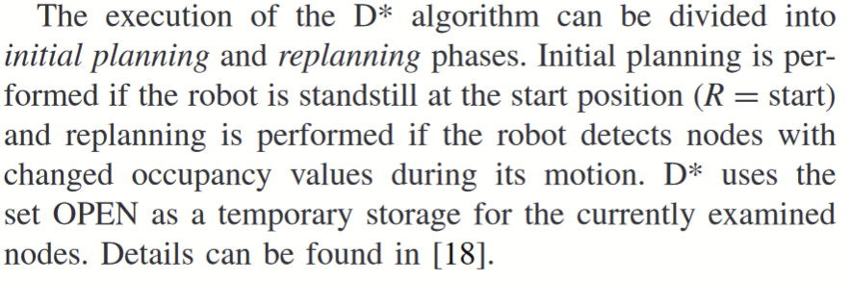p1325
17. Rest of it was experimental results, it does work

**Paraphrased Notes: *Include Page #s*** (This is a space for you to track the flow of information, and the ways in which the article engages with other works.)

**Summary of Source (2-4 sentences)**

**OH MY GOD THIS IS SO COOL! It takes the A* algorithm and the D* algorithm and mashes them together to create an amazing live updating path plan, WITH LOCALIZATION POINTS!! It’s so simple yet so amazing.**

**Does this help me answer my question? Why or why not?**

**Yep, SLAM once again, not really talking about robotic use except for having Lidar on a car but thats it.**

**Lingering Questions**

**Connections to other sources**